2011 Coastline All College Spring Workshop Evaluation Survey
“Let the Games Begin!”

39 attendees (67% responded to this survey)

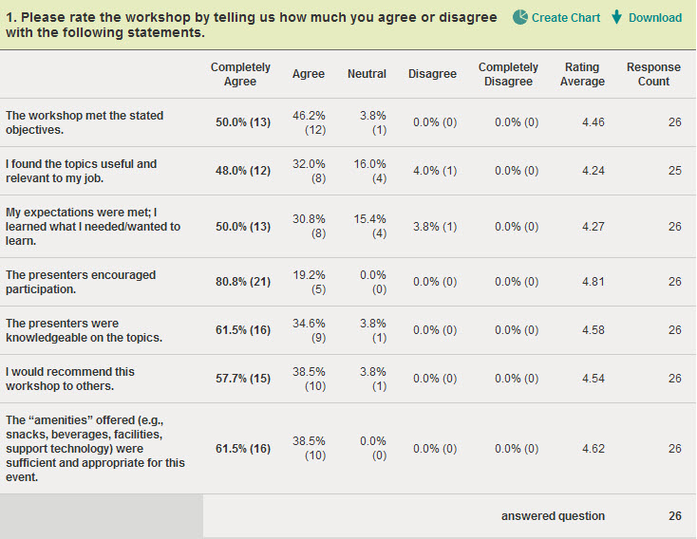

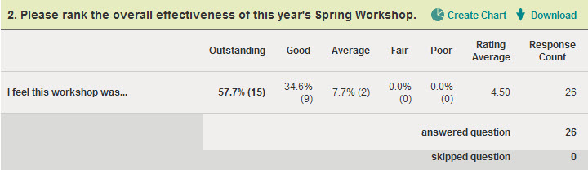
3. What did you like most about this year's Spring Workshop?
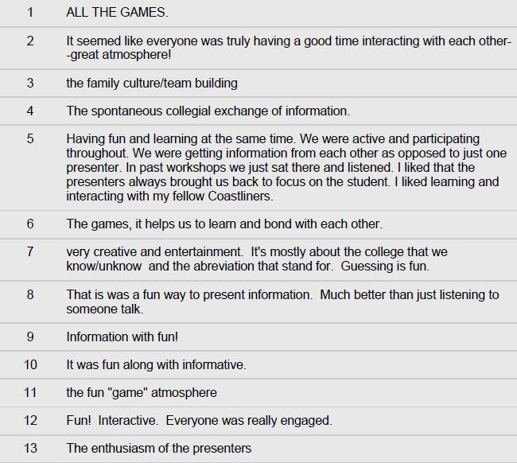
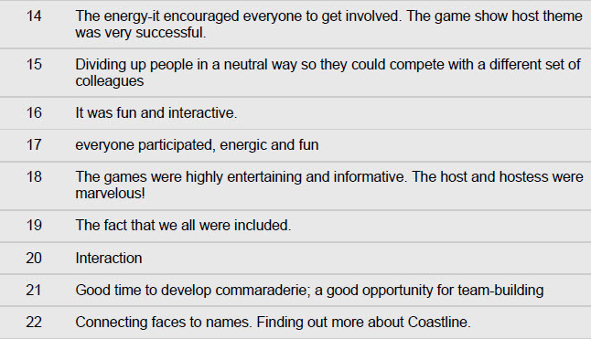
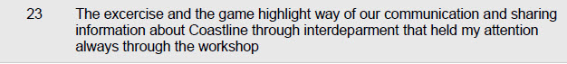
4. What did you like least about this year's Spring Workshop?
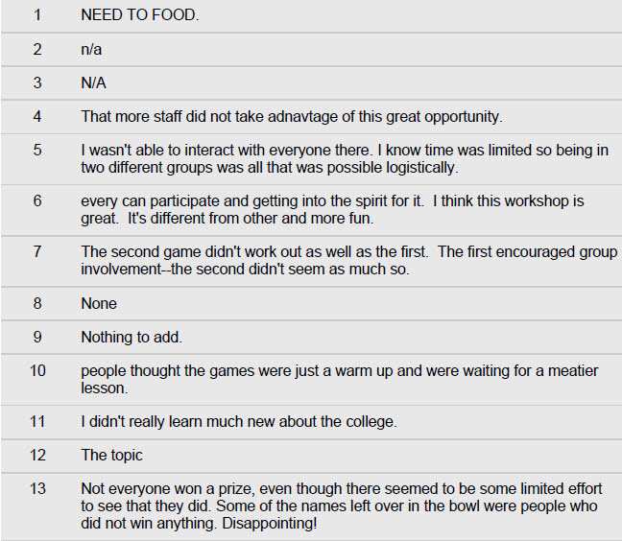
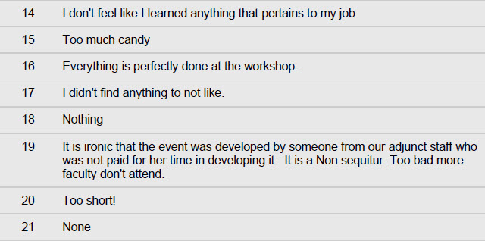
5. What recommendations do you have for improvement? How could we have made this workshop more effective or enjoyable?
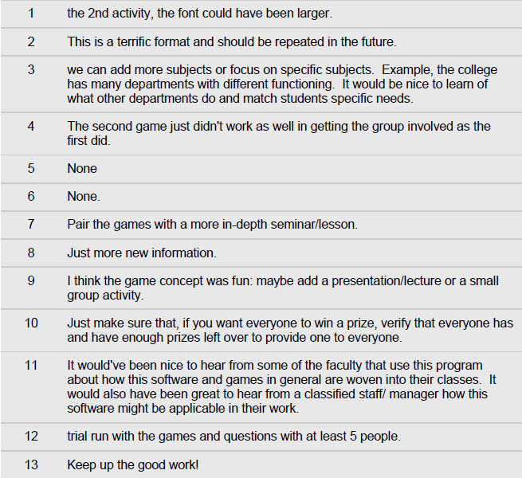
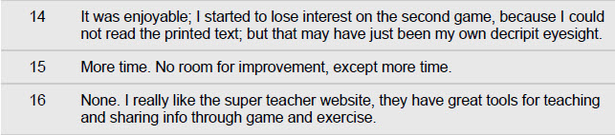

6. Would you attend any additional or follow-up training in this general subject area? And, if so, what topics would you like to see presented?
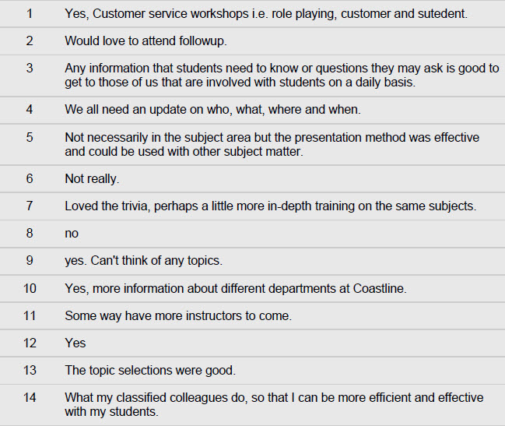

7. What other topics would you like us to consider for next year's All College Spring Workshop?


